ENVIRONMENTAL PRODUCT DECLARATION (EPD)
ACCORDING TO ISO 14025 & 15804+A2
Product: onyx Traverse 2400/04 + 2444/99

Environmental Product Declaration (EPD)
An Environmental Product Declaration (EPD) is a Type III environmental declaration that quantifies environmental information about the life cycle of a product. This can enable comparisons between products fulfilling the same function. The methodology to produce an EPD is based on the full product life cycle assessment (LCA), following the ISO 14040 series of standards.

onyx Traverse 2400/04 + 2444/99
Looking for a stylish and smart design for waiting and reception areas? You no longer have to wait for the ideal solution. Because Casala offers infinite possibilities with Onyx beam seating. This includes various shell options and a rich variation in upholstery. The Onyx beam seating blends perfectly with the Onyx waiting room chairs.  Casala’s production facility has a solar park which produced 4.5t Kwh in 2023. The remaining energy needed is produced by European Wind as stated by the supplier. The production facility and almost all 3rd parties are ISO 9001 & 14001 certified. | 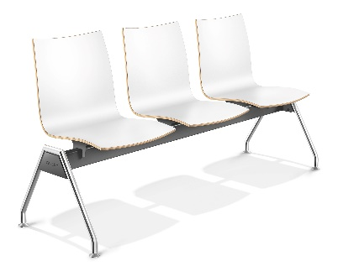
Variant | 4 seater frame, shelll CPL
Base | Welded steel chassis
Finish | Powder coated and Chromium III*
Technical life span | 15 years
Dimensions (HxLxW) | 84 x 53 x 234 cm
Weight | 35.4 kg
Packaging weight | 0.1 kg
*The frame is environmental chromed according to the Chrome-III procedure which fulfils the strictest requirements for REACH and CSR guidelines.

Global Warming potential
To quantify and compare results, we use the Global Warming Potential (GWP) expressed in kg CO₂-equivalent. This is a measurement method for finding out the amount of energy required to emit 1 tonne of a gas, which is absorbed over a 100-year period. The greater the GWP, the more a particular gas warms the earth.

To comply with EN ISO 15804+A2, Casala uses the ‘cradle to grave’ assessment for their EPD files. The assessment covers the full life cycle of a product; from production phase to use, followed by recycling or disposal. Other EPD files often only use the ‘cradle to gate’ assessment, which only covers the production phase.

GWP per unit (Cradle to Grave) | 38.375 kg CO₂eq.
GWP per unit (Cradle to Gate) | 59.465 kg CO₂eq.
Average GWP for beam seating according to the Furniture Industry Research Association (Cradle to Gate) | 66.000 kg CO₂eq.

The assumed percentage of waste processing
Landfill | 2.72 %
Incineration | 31.38 %
Recycling | 59.07 %
Re-use | 6.83 %

Document information
Calculation number | ReTHiNK-120131
Declaration owner | Casala
Publisher | Casala
Program operator | Casaro
LCA software | NIBE - R<THINK LCA
Status | Valid

www.casala.com

